
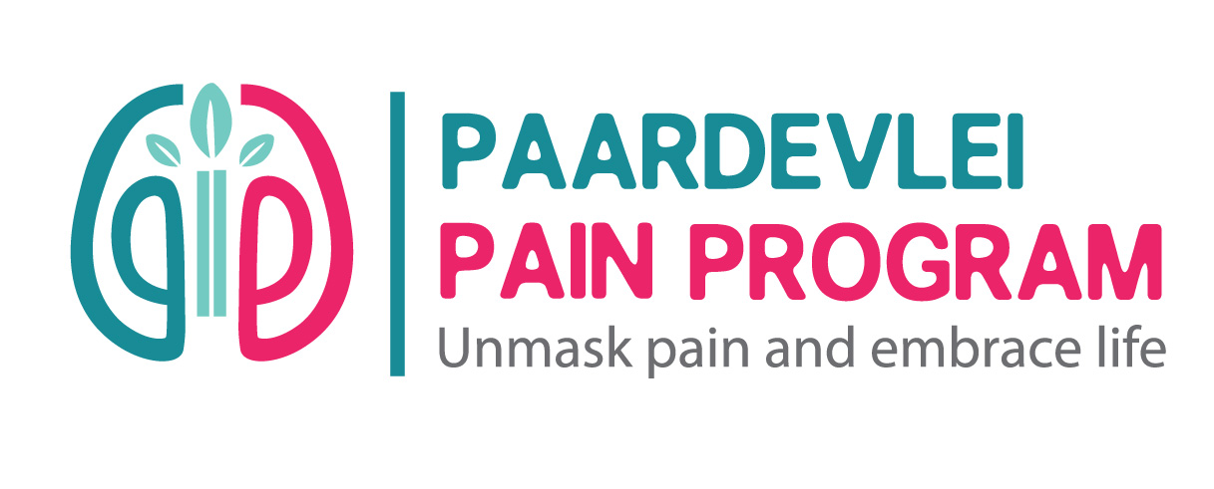
“Piece from a Physiotherapist perspective—both personal and professional- reflecting on the value that the Nia Art of Sensation training has offered you from a physiotherapist’s point of view.”

I discovered Nia Movement classes more than 20years ago. As a Physiotherapist and lifelong ballet dancer, I always recognized the value of Nia as an exercise and movement modality. I attended classes on and off over the years and always thoroughly enjoyed it.
However, it was only during the The Art of Sensation White Belt Training with Mia in 2024, that I truly realized the value of Nia for myself.

In October 2021, my life came to a dead standstill after a major MBA, in which I sustained many fractures all over my body and was immobilized in hospital for 7 weeks. Emotionally and physically, it was an uphill battle to make peace with my “new” body. I suffered from PTSD from the medical trauma and extreme pain I experienced in hospital, and I was unable to return to life and my career as I knew it before the accident. I had a wonderful support system from my husband, family, friends and colleagues, but the journey to recover from a big trauma can be a lonely and difficult one within yourself, despite all your external support and therapy.

Working through all the Principles of Nia during the 7-day course, I re-discovered my body and life through all my senses from a totally new perspective. It taught me skills to make better decisions / choices every day and to consciously choose life and how I want to live it from day to day. I learned to sense what my body needed and how to move in my own body’s way (which is different from day to day).
Nia incorporates so much in the movement sessions: mobilizing joints, nerves and fascia; increasing flexibility and stability; improving balance and co-ordination, expression, teaching your nervous system to regulate better and so much more in a safe space where there is no judgement.

I was blown away by all the research and purposeful design, that has gone into putting the Nia Movement Routines together. It is not only a form of exercise, to me, it is movement therapy. It is one of the few movement modalities, which address Body, Mind and Soul – the whole Bio-Psycho-Social model in one.
The beauty of the principles is that it can be applied to everyday life, and the movements can be adapted to suit anyone, no matter their limitations physically, mentally or emotionally. Most valuable of all - it has helped me to find Joy. The Art of Sensation Course has been a catalyst in my life and Mia an amazing mentor, helping me find a new way forward.

I did the Art of Sensation Course for myself, for my own healing. As health care providers, we seldom invest in our own health and wellbeing, but I now realize more than ever, that it is crucial to take care of ourselves, so that we have the energy and ability to help others. In functioning better within ourselves, it ripples out to our families and in our Professions to our patients.

In discovering the principles and the full value of Nia for myself, I have also realized how valuable a tool it is to apply in my practice to also help my patients. Nia has become an integral part of my life. The Principles of Nia is very much in line with the Therapeutic Neuroscience Education Principles we use to treat patients with pain. It is now a complimentary tool in my practice, and I am very passionate about sharing this amazing movement modality with others.

I encourage you to invest in your own health and experience the Nia Principles for yourself in the Art of Sensation Course!

15 Landdroskop Drive, Erinvale Golf Estate, Somerset West,7130 /
Postnet Suit #925, Private Bag X15, Somerset West, 7129
Cell: 0834065901 / email: info@leescottphys.

